|  |
| --- |
|  |
| TARGET FAT GALICIA |
|  |

|  | Name | Role/Title |
| --- | --- | --- |
| Owner | Anders Sandström | Electronics Engineer Motion Control & Automation |
| Reviewer |  |  |
| Approver |  |  |

TABLE OF CONTENT PAGE

1. Background 4

1.1. Equipment in scope 4

2. Requirements 5

3. CONTROL SYSTEM 6

3.1. Hardware 6

3.2. EL5021 Encoder interface 7

3.3. EL3174 Analog interface 7

3.1. ILD2300 Position sensor 8

4. Test Execution 8

5. METHOD 9

5.1. Rotation velocity stability 9

5.2. Rotation traction difference over revolution 9

5.3. Rotor displacement amplitude 9

5.3.1. Rampup 9

5.3.2. Steady state 9

5.3.3. Rampup 9

5.3.4. Rampdown 10

5.3.5. Rampup 10

6. Analysis 11

6.1. Rotation velocity stability 11

6.2. Torque variations during velocity ramp down 11

6.3. Rotor Displacement 15

6.3.1. Rotor Displacement during velocity ramp up 15

6.3.2. Rotor displacement over 10h (horizontal pedestal sensors) 16

6.3.1. Rotor circumference displacement over 10h (optical sensor) 18

7. Results 19

7.1. 11359 Axis 1 20

8. CONCLUSIONS 20

9. references 21

10. Appendix A Micro Epsilon ILD2300 Calibration REPORT 22

11. Appendix B: Telemess A30-S01 23

12. Appendix C: Telemess A42 24

list of tables

Table 1: Statistics for horizontal pedestal sensors over a 10h period. 18

Table 2: Statistics for horizontal optical sensor measuring circumference position deviation over a 10h period 19

Table 3: Results 11359, axis 1 21

list of Figures

Figure 1: Target wheel, shaft and drive unit 4

Figure 2: Control hardware 6

Figure 3: Amo rotational sin/cos encoder 7

Figure 4: Telemess eddy current sensor positions 7

Figure 5: ILD2300 triangulation sensor 8

Figure 6: Ramp down from 23 rpm (lower = position, center=velocity, upper=velocity-minus linear component). 12

Figure 7: Velocity for each rev vs rotation angle and time (linear velocity component removed) 12

Figure 8: Ramp down from 28 rpm (lower = position, center=velocity, upper=velocity-minus linear component). 13

Figure 9: Velocity for each rev vs rotation angle and time (linear velocity component removed) 14

Figure 10: Rotor positions measured with the 5 position sensors 15

Figure 11: Position measurements for horizontal sensors at 0º, 120º and 240º degrees over a 10h period. Upper graph shows maximum position values and lower graph shows minimum position values. Each value is a maximum or minimum of a 10 second period. 16

Figure 12: Manual recorded rotation drive torque [7] 17

Figure 13: Position measurements for the optical sensor measuring circumference deviation over a 10h period. Upper graph shows maximum position values and lower graph shows minimum position values. Each value is a maximum or minimum of a 10 second period. 19

# Background

The target wheel and drive unit FAT took place week 7 2022 at Thune Eureka premises in Galicia Spain. This report contains analysis of some data acquired during the FAT tests.

## Equipment in scope

The target wheel and shaft assembly can be seen in Figure 1.

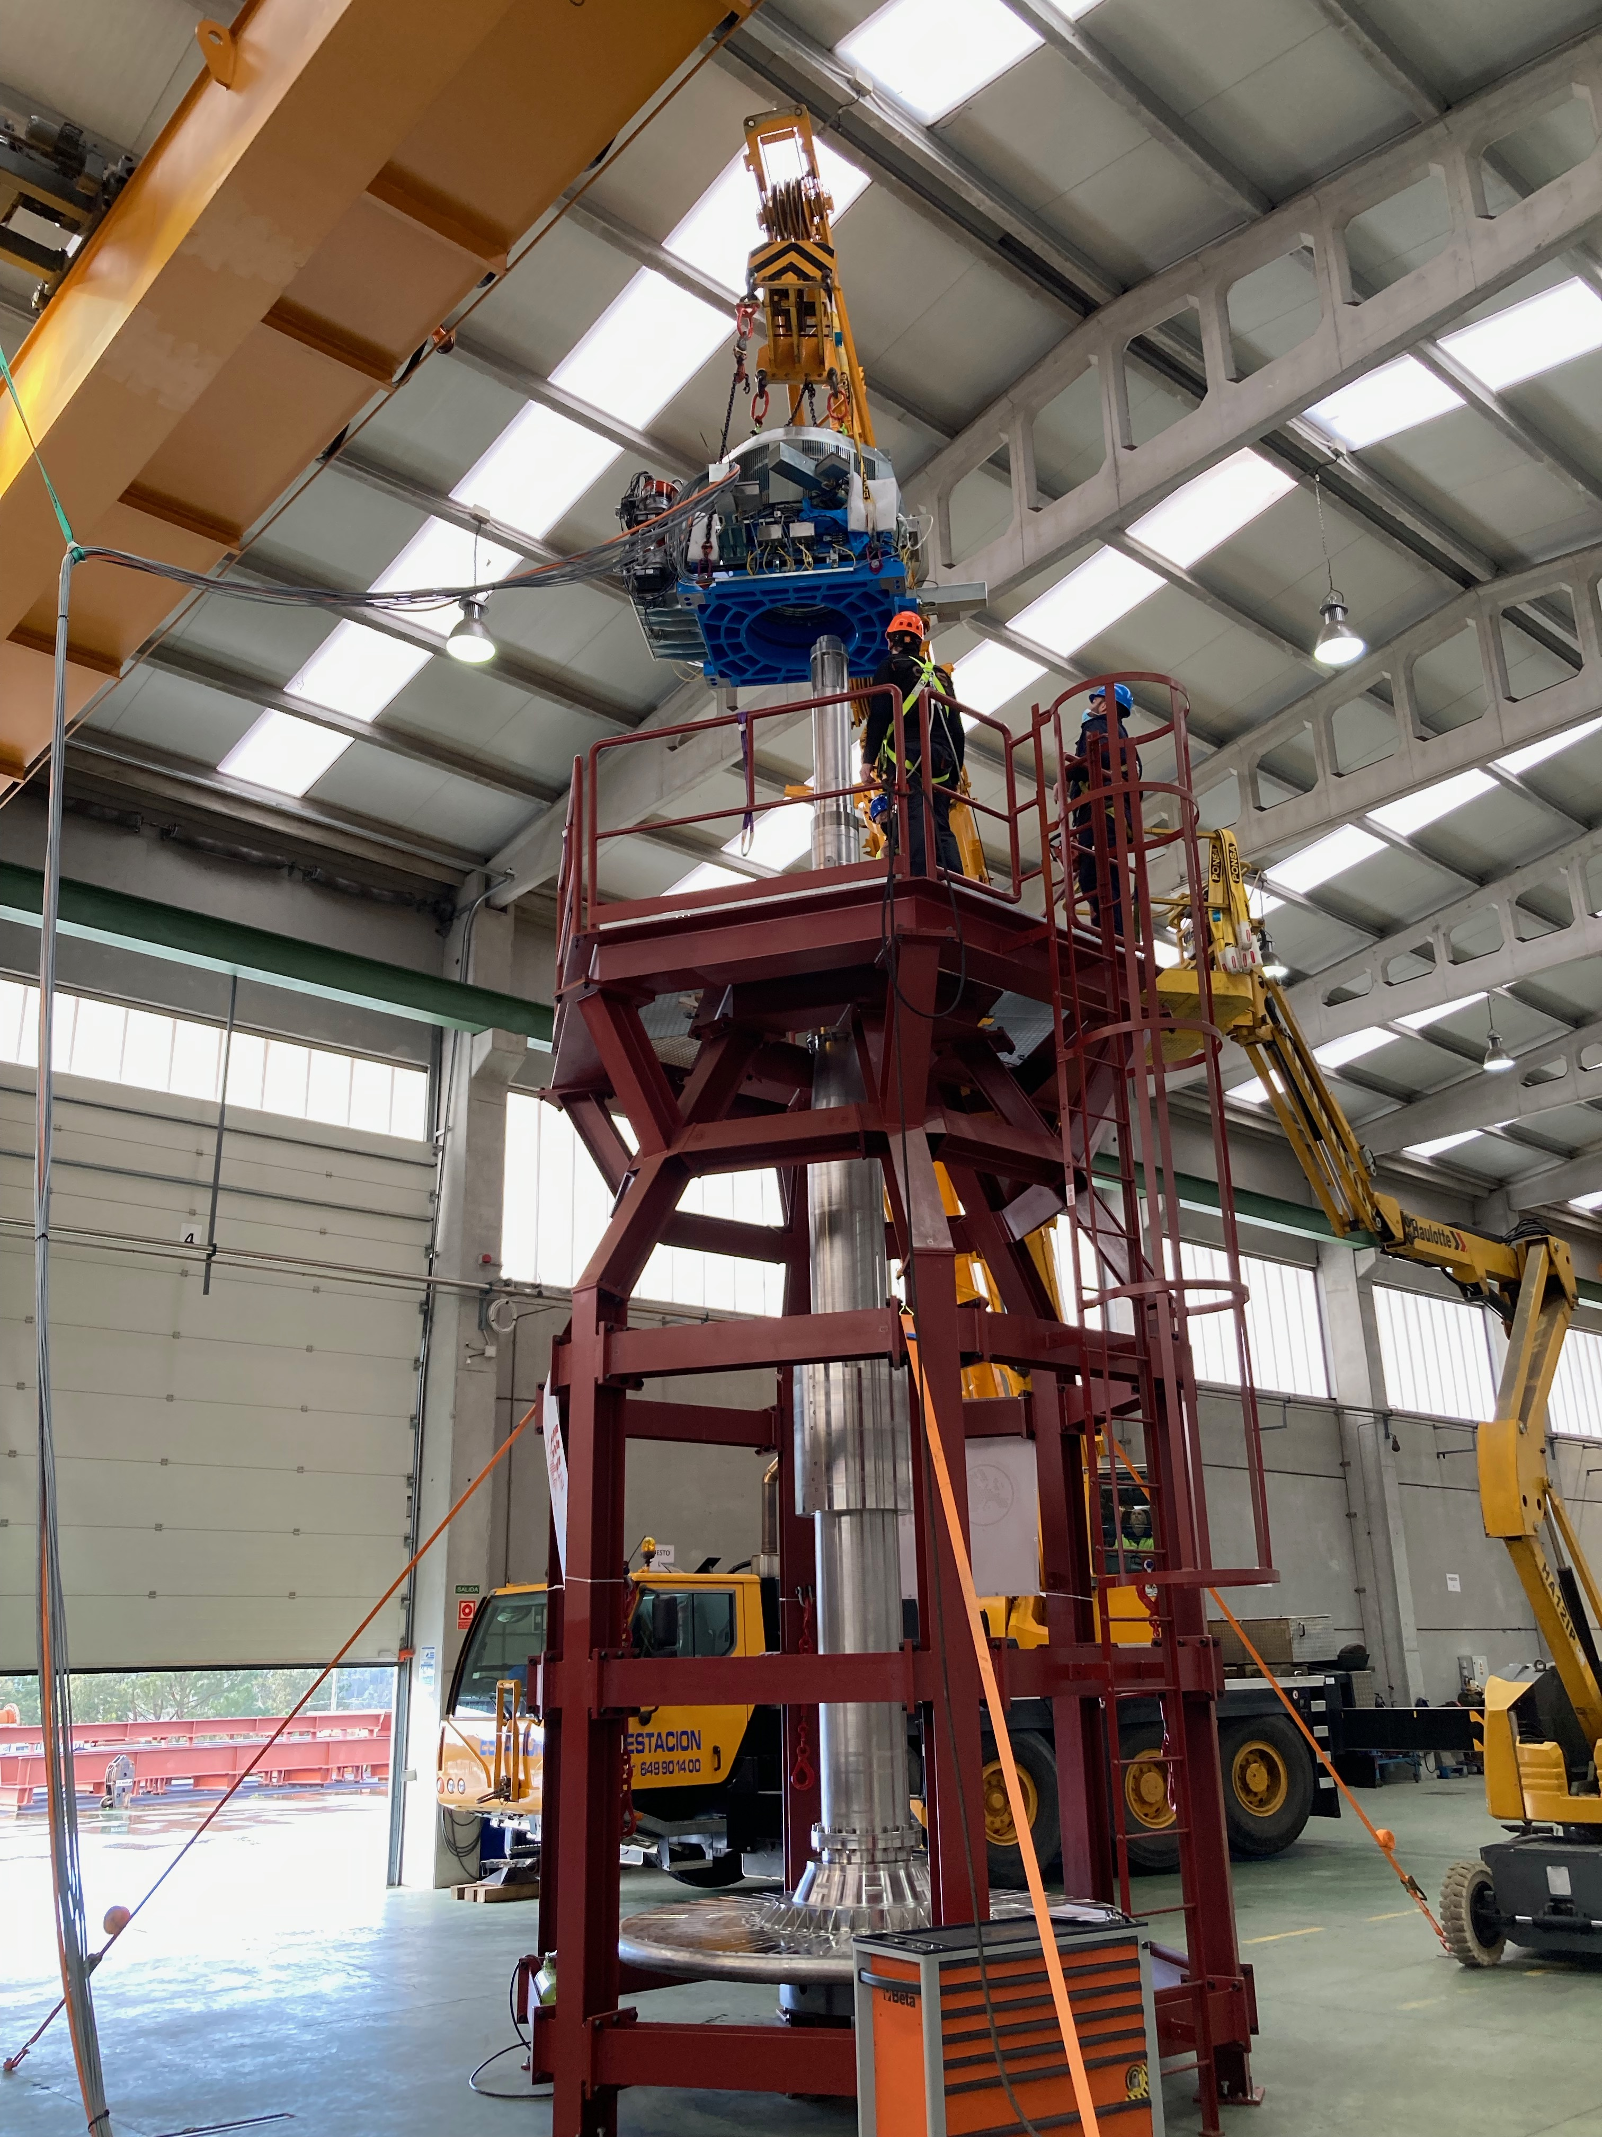

Figure 1: Target wheel, shaft and drive unit

# Requirements

The following requirements have been set by the BIFROST team:

1. Stroke: 40mm
2. Accuracy: +-0.1mm
3. Repeatability: +-0.05mm
4. Resolution: 0.01mm minimum

# CONTROL SYSTEM

The FAT measurements were performed with an EtherCAT [1] based control system, ecmc [2]. The configuration files for the SAT have been added to a git repository [3]. All hardware needed for the tests have been integrated into the same system which then leads to that all sampled data have the same time base.

The actual control of the X,Y,Z and rotational motors was handled with other control system.

## Hardware

The following control hardware was used, Figure 2:

1. EL5021: 1ch sin/cos encoder interface for Amo rotational eddy current sensor
2. EL3174: 4ch analog input for Telemess eddy current sensors [5]
3. ILD2300: Micro Epsilon laser triangulation sensor [4].

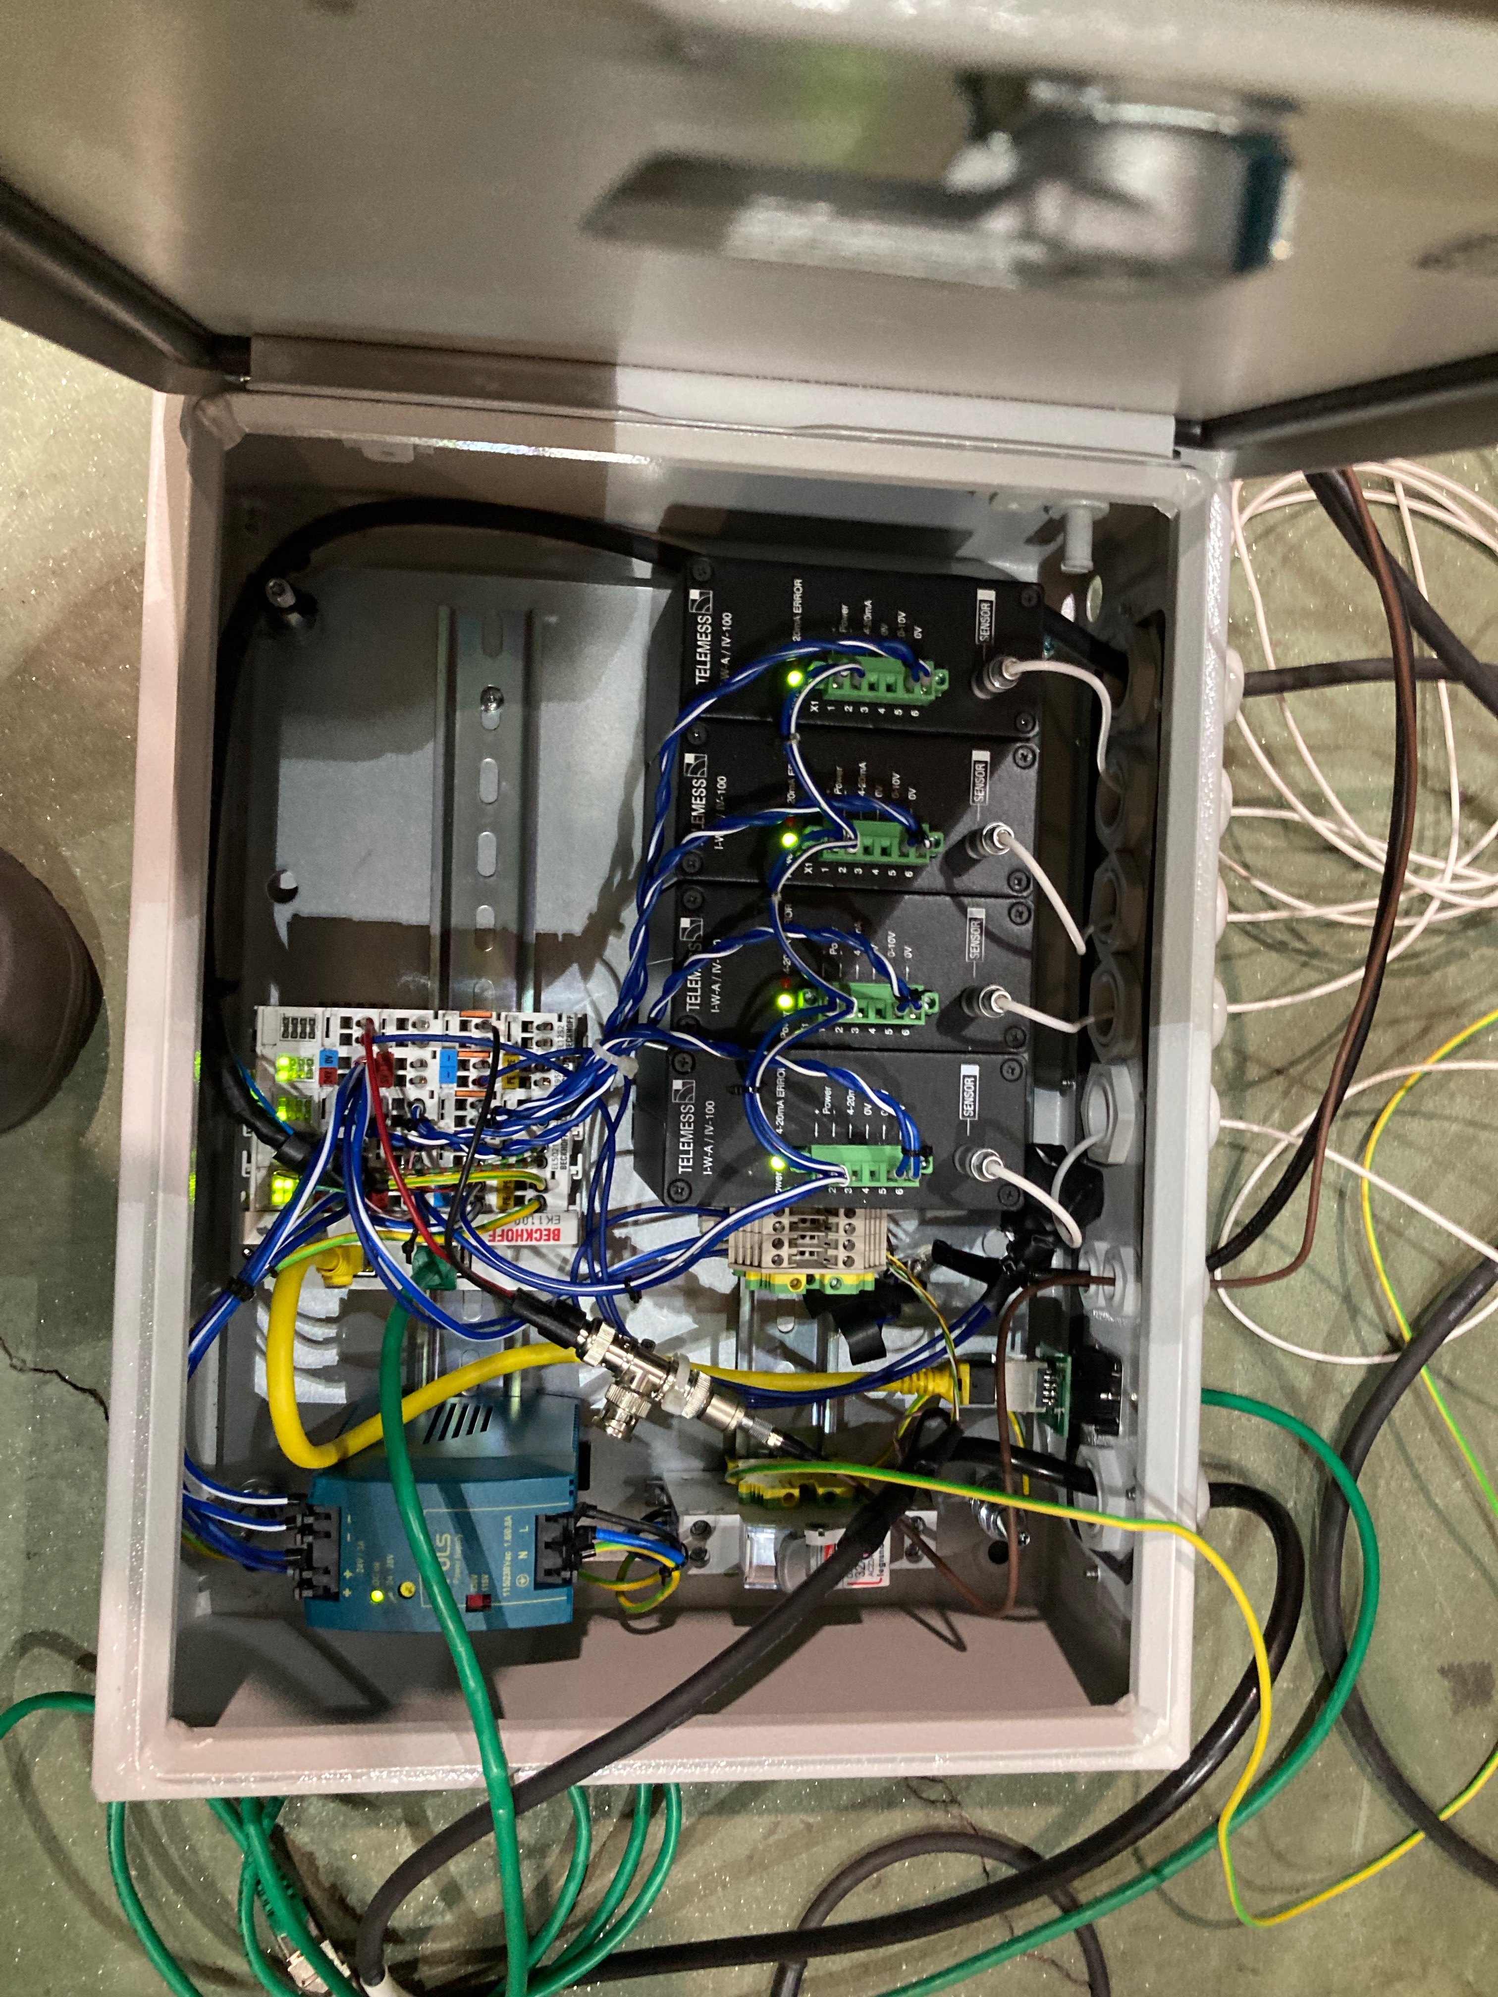

Figure 2: Control hardware

## EL5021 Encoder interface

The EL5021 sin/cos interface was connected to one of the two AMO rotational encoder of the target wheel measuring rotational position, Figure 3.

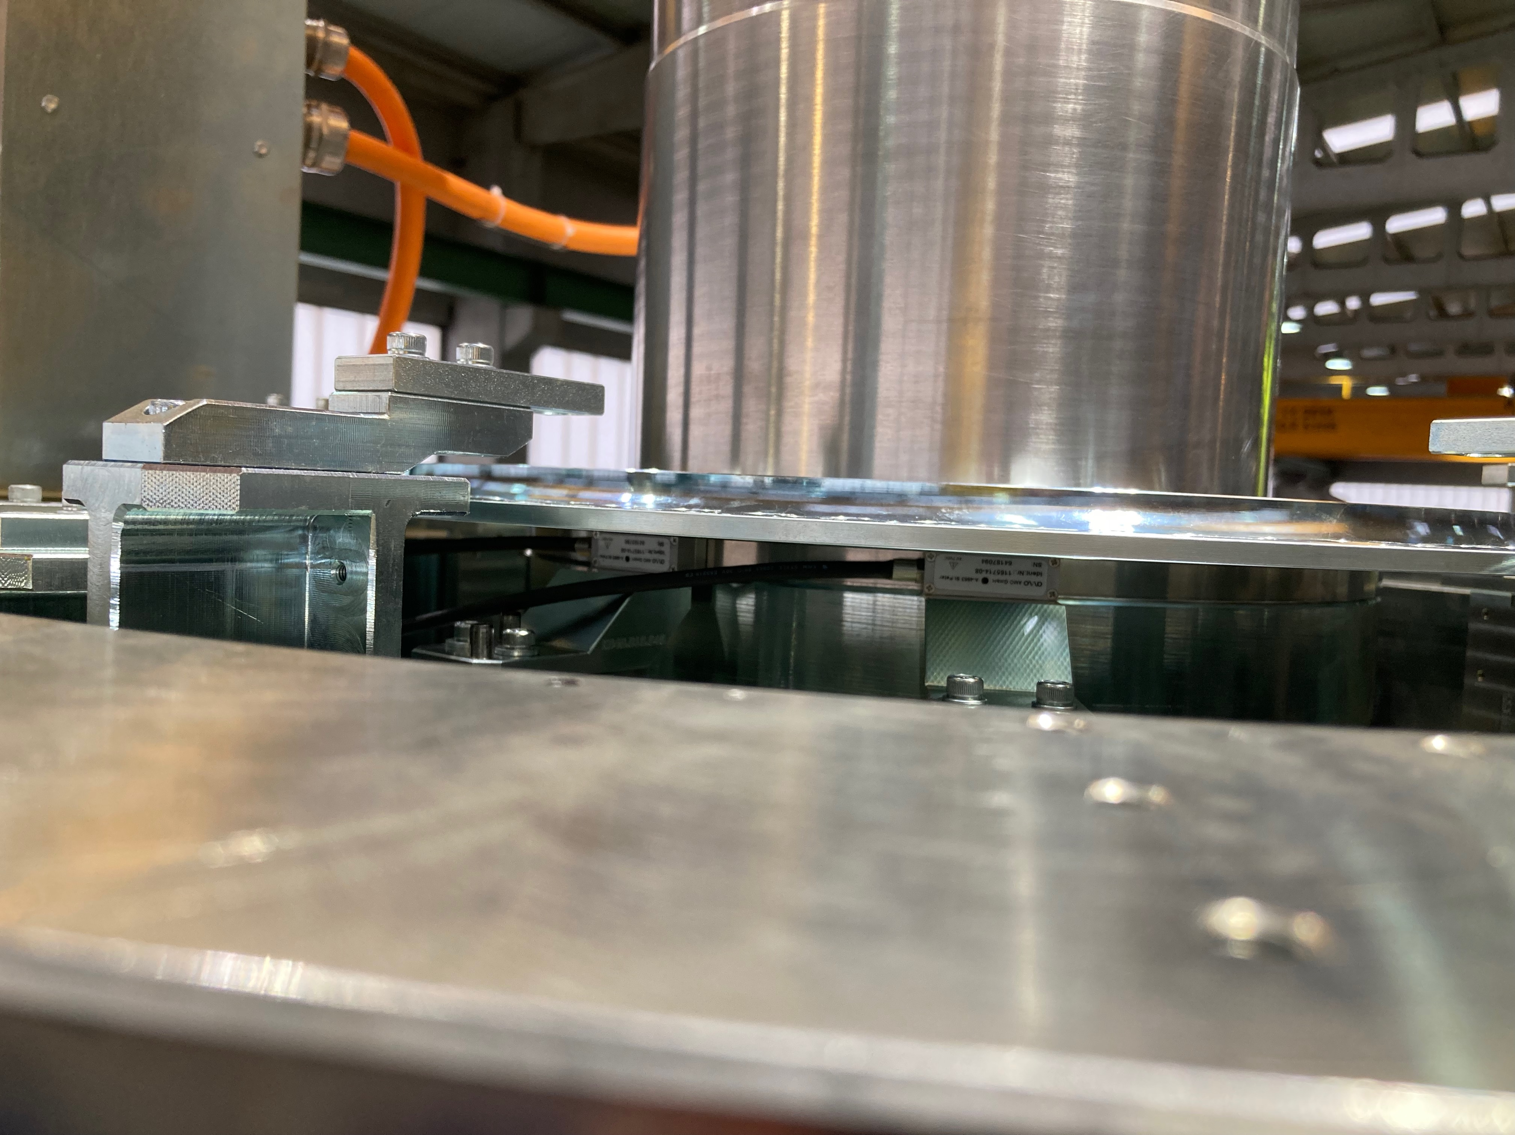

Figure 3: Amo rotational sin/cos encoder

## EL3174 Analog interface

The EL3174 analog interface was used to interface 4 Telemess analog eddy current position sensors. Three sensors of type A30-S01, Appendix B: Telemess A30-S01, were mounted in the horizontal plane with an angular offset of 120 degrees, the fourth sensor of type A42, APPENDIX C: Telemess A42, was mounted vertically from underneath the pedestal, Figure 4.

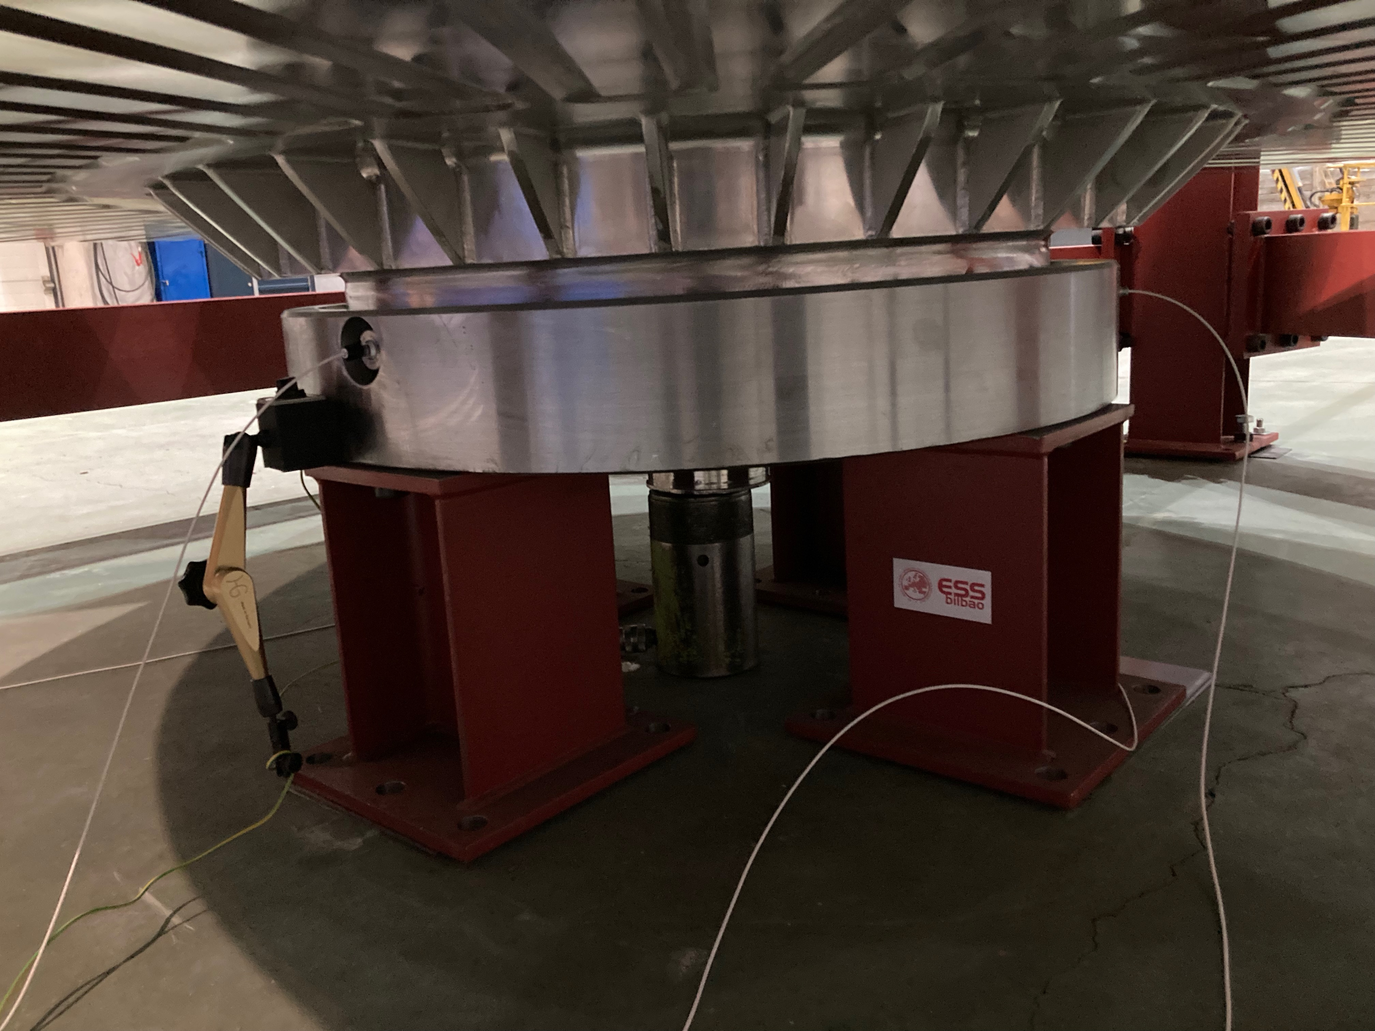

Figure 4: Telemess eddy current sensor positions

The sensor signals were all linearized according in the control system based on calibration data sheets from the supplier, [6].

## ILD2300 Position sensor

The ILD2300 optical triangulation sensor was mounted to measure directly on the circumference of the target wheel, Figure 5.

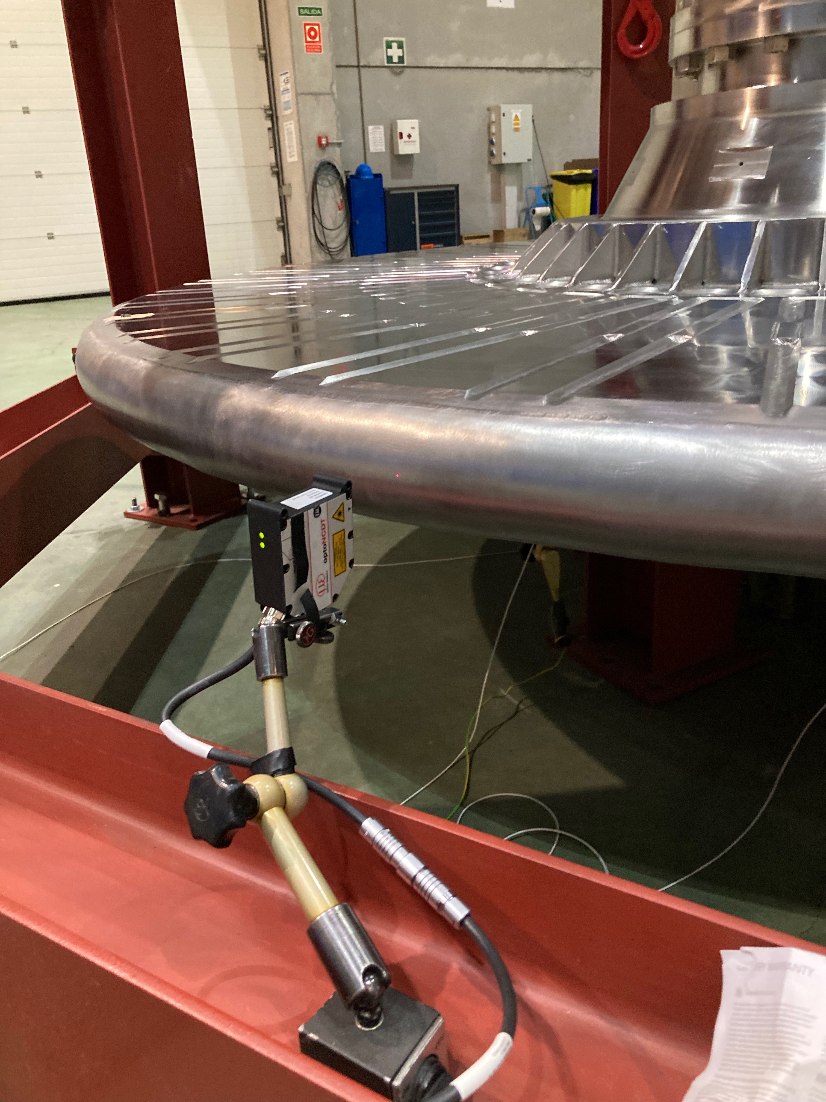

Figure 5: ILD2300 triangulation sensor

The Micro Epsilon ILD2300 sensor interfaces directly over and have the following specs:

1. Range: 50mm
2. Linearity: +-10 μm (protocol: Appendix A Micro Epsilon ILD2300 Calibration)
3. Resolution: 0.8 μm

# Test Execution

The FAT was executed during week 7, 2022 at Thune Eureka premises in Galicia. The activities for each day of the week was:

* Monday: Assembly of drive unit and commissioning of control and measurement systems
* Tuesday: Continue commissioning of control and measurement systems, test rotation and x,y,z stepper movements.
* Wednesday: 12h rotation test
* Thursday: Focus on x, y, z stepper axes tests and some rotation tests
* Friday: Disassembly and preparation for shipment of components to Lund.

# METHOD

## Rotation velocity stability

Velocity was measured by differentiating the position value of the rotational encoder. The velocity signal was then averaged over one sector, 10 degrees, in order to filter noise mainly derived from high sample rate of the encoder signal. The velocity stability then calculates as the maximum spread of the velocity signal over a time period.

## Rotation traction difference over revolution

Traction difference over the rotor revolution was measured by analysing the deceleration rate of the rotor with motor disabled (power less).

## Rotor displacement amplitude

The maximum rotor displacement was measured by 5 positional sensors:

* 3 eddy current sensors mounted in the horizontal x,y-plane in the pedestal, displaced 120 degrees.
* 1 eddy current sensor mounted in the z direction in the pedestal
* One optical triangulation sensor measuring the displacement of the circumference of the target wheel outer surface. The optical sensor was also used for calibration of the eddy current sensors by replacing and comparing it to the eddy current sensor positioned at 120 degrees.

### Rampup

#### X-Y

#### Z

#### Rotor circumference

### Steady state

### Rampup

X-Y

Z

Rotor circumference

### Rampdown

### Rampup

X-Y

Z

Rotor circumference

# Analysis: Rotation Torque

## Torque during velocity ramps

Encoder angular position data was sampled during ramp down with motor disabled meaning only the traction in the system, mostly in bearings, and inertia of the rotor will affect the deceleration ramp (no torque on motor). The zero value of the angular position is defined by a reference mark on the encoder ring and can therefore be used as an absolute angular reference of the wheel.

The lower graph in Figure 3 shows the angular position during ramp down from 23 to 0 rpm in unit degrees. Each red vertical line indicates one full revolution.

Velocity is calculated by differentiating the position value from the rotational encoder (center graph). The total time to ramp down from 23rpm to 0 is approximately 94 seconds.

The average traction torque can be calculated by:

$=I*$

τ = Torque [Nm]

I = Inertia [kgm2] = 5260kgm2

α = angular acceleration [rad/s2], 23rpm to 0 rpm in 94s

The average traction torque can then be calculated to approx. 135Nm.

Unfortunately, the velocity values are too noisy to differentiate into acceleration. Instead the upper graph shows the velocity but without the pure linear deceleration component generated by the 135Nm traction. It can be concluded from the upper graph that the deceleration is not constant during the ramp down process and also varies cyclically within each revolution.



Figure 6: Ramp down from 23 rpm (lower = position, center=velocity, upper=velocity-minus linear component).



Figure 7: Velocity for each rev vs rotation angle and time (linear velocity component removed)

Detailed velocity changes for each revolution from the upper graph in Figure 3 is plotted in Figure 4, the upper graph shows velocity vs angular position and the lower graph shows velocity vs time. A polynomial fit for the dataset of each revolution is also plotted in the same color as the raw velocity data. All revolutions show a similar shape where in the first part of the revolution the deceleration is faster than in the second part of the revolution. This could be an indication that the traction torque is not same over the revolution. By analyzing the slope of polynomial fits it can be concluded that the torque difference within the revolution is in the order of +-10Nm in average for the analyzed revolutions. Another reason for this velocity change could be that the whole frame is oscillating resulting in cyclic displacement of the encoder reading head and therefore a cyclic overloaded sinusoidal disturbance in the encoder position.

In order to verify the results a second test with ramping down from 28rpm was executed. Unfortunately, the data acquisition was stopped to early at approx. 1rpm, Figure 9, Figure 10.



Figure 8: Ramp down from 28 rpm (lower = position, center=velocity, upper=velocity-minus linear component).



Figure 9: Velocity for each rev vs rotation angle and time (linear velocity component removed)

The ramp down from 28rpm shows similar behavior to the ramp down from 23rpm.

## Torque at constant velocity

Rotational torque from the motor drive was manually recorded each 10 minutes during the 10h rotation test, Figure 10.

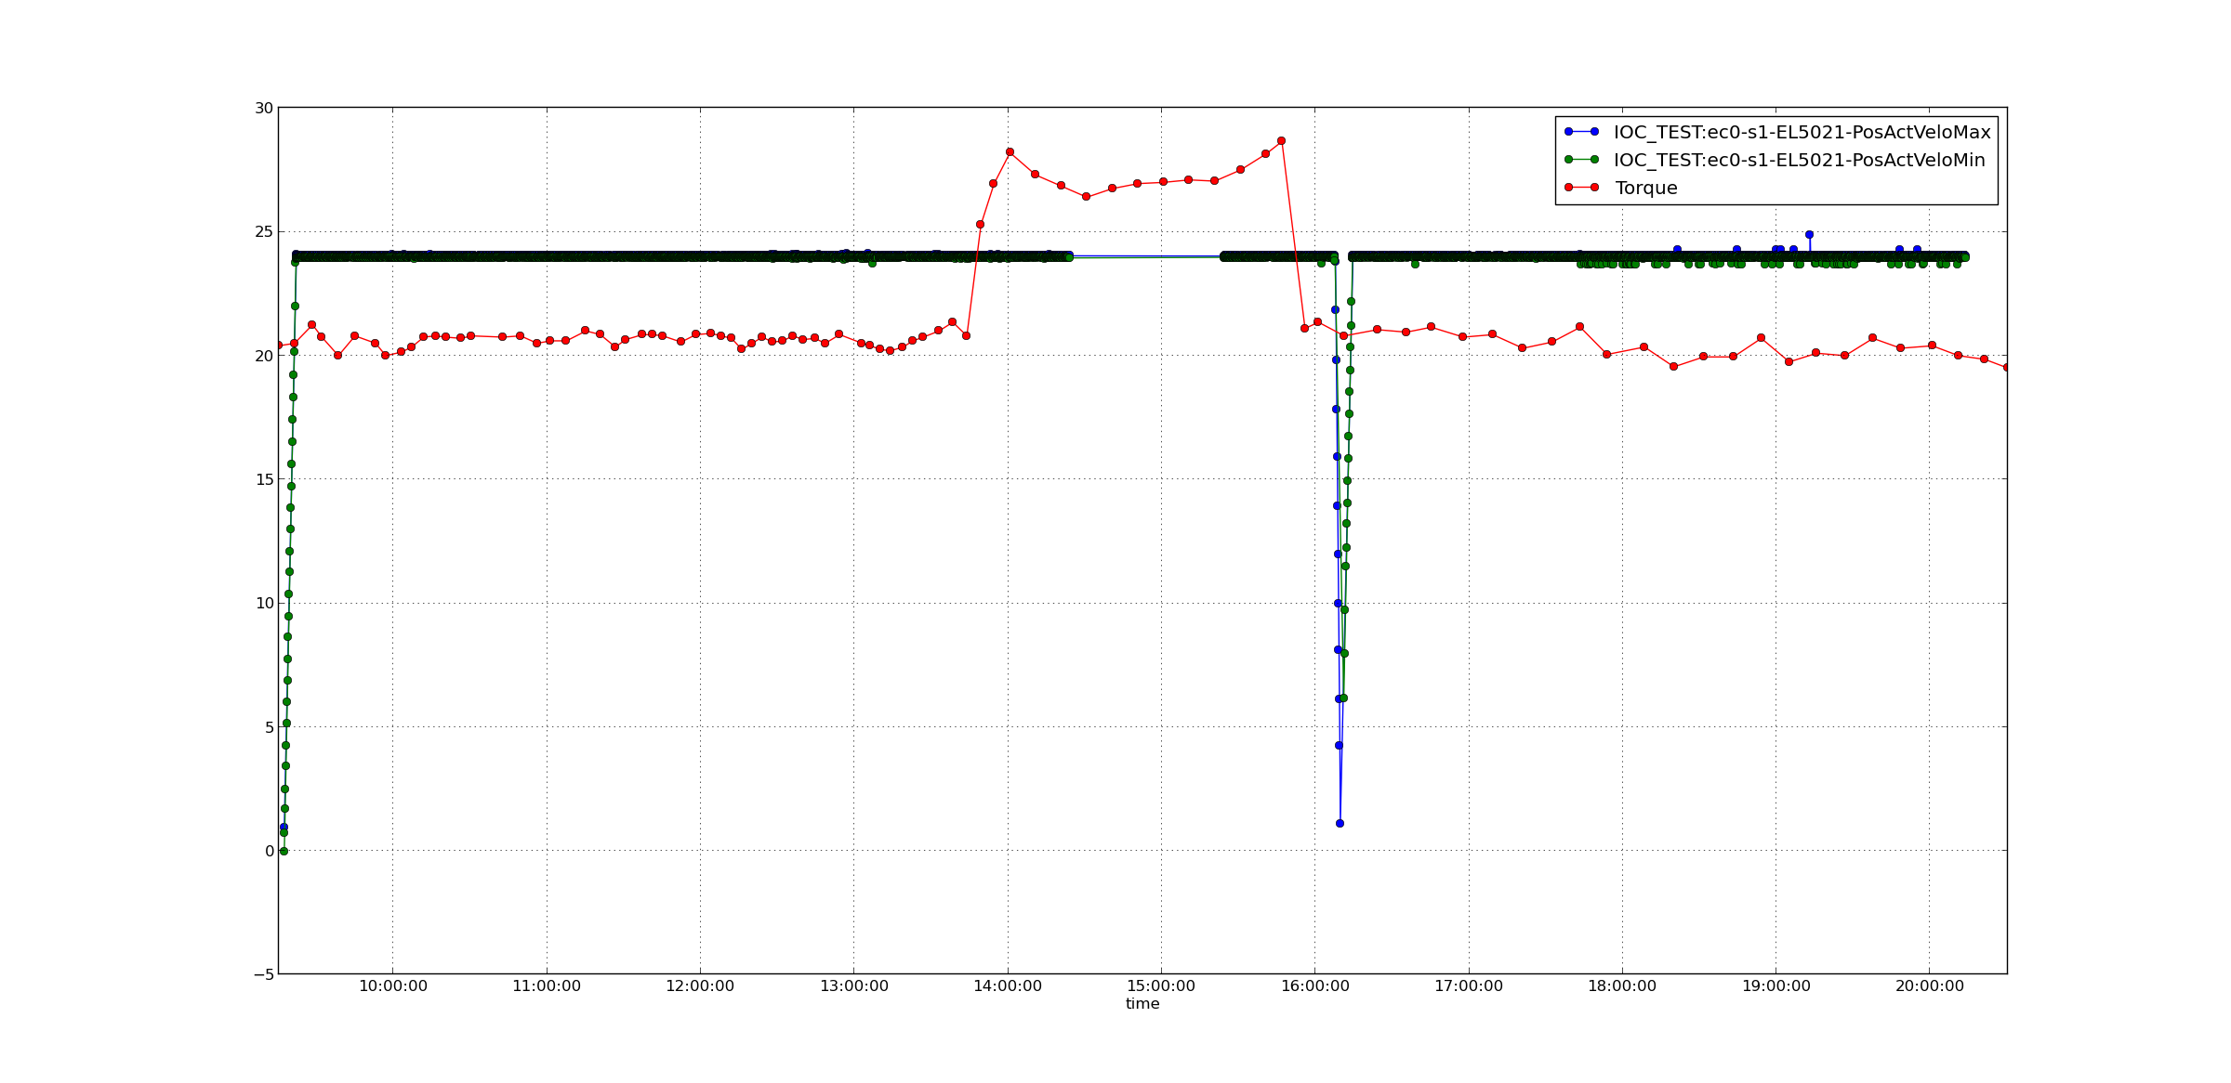

Figure 10: Manual recorded rotation drive torque [7]

## Rotor Displacement

The 5 positional sensors where used to measure rotor displacement. Figure 11 shows a few minutes of data recorded at a constant velocity of 23rpm. All sensors register a cyclic position distribution in the frequency of the target wheel rotation. In the graph for the vertical sensor values some outliers can be seen, these are generated by a whole of size M24 passing then sensor, therefore these outliers are not relevant and should be ignored. The optical sensor also show high and low peak values for each revolution which is believed to be generated by a passing vertical weld, hence these values are relevant in the analysis.

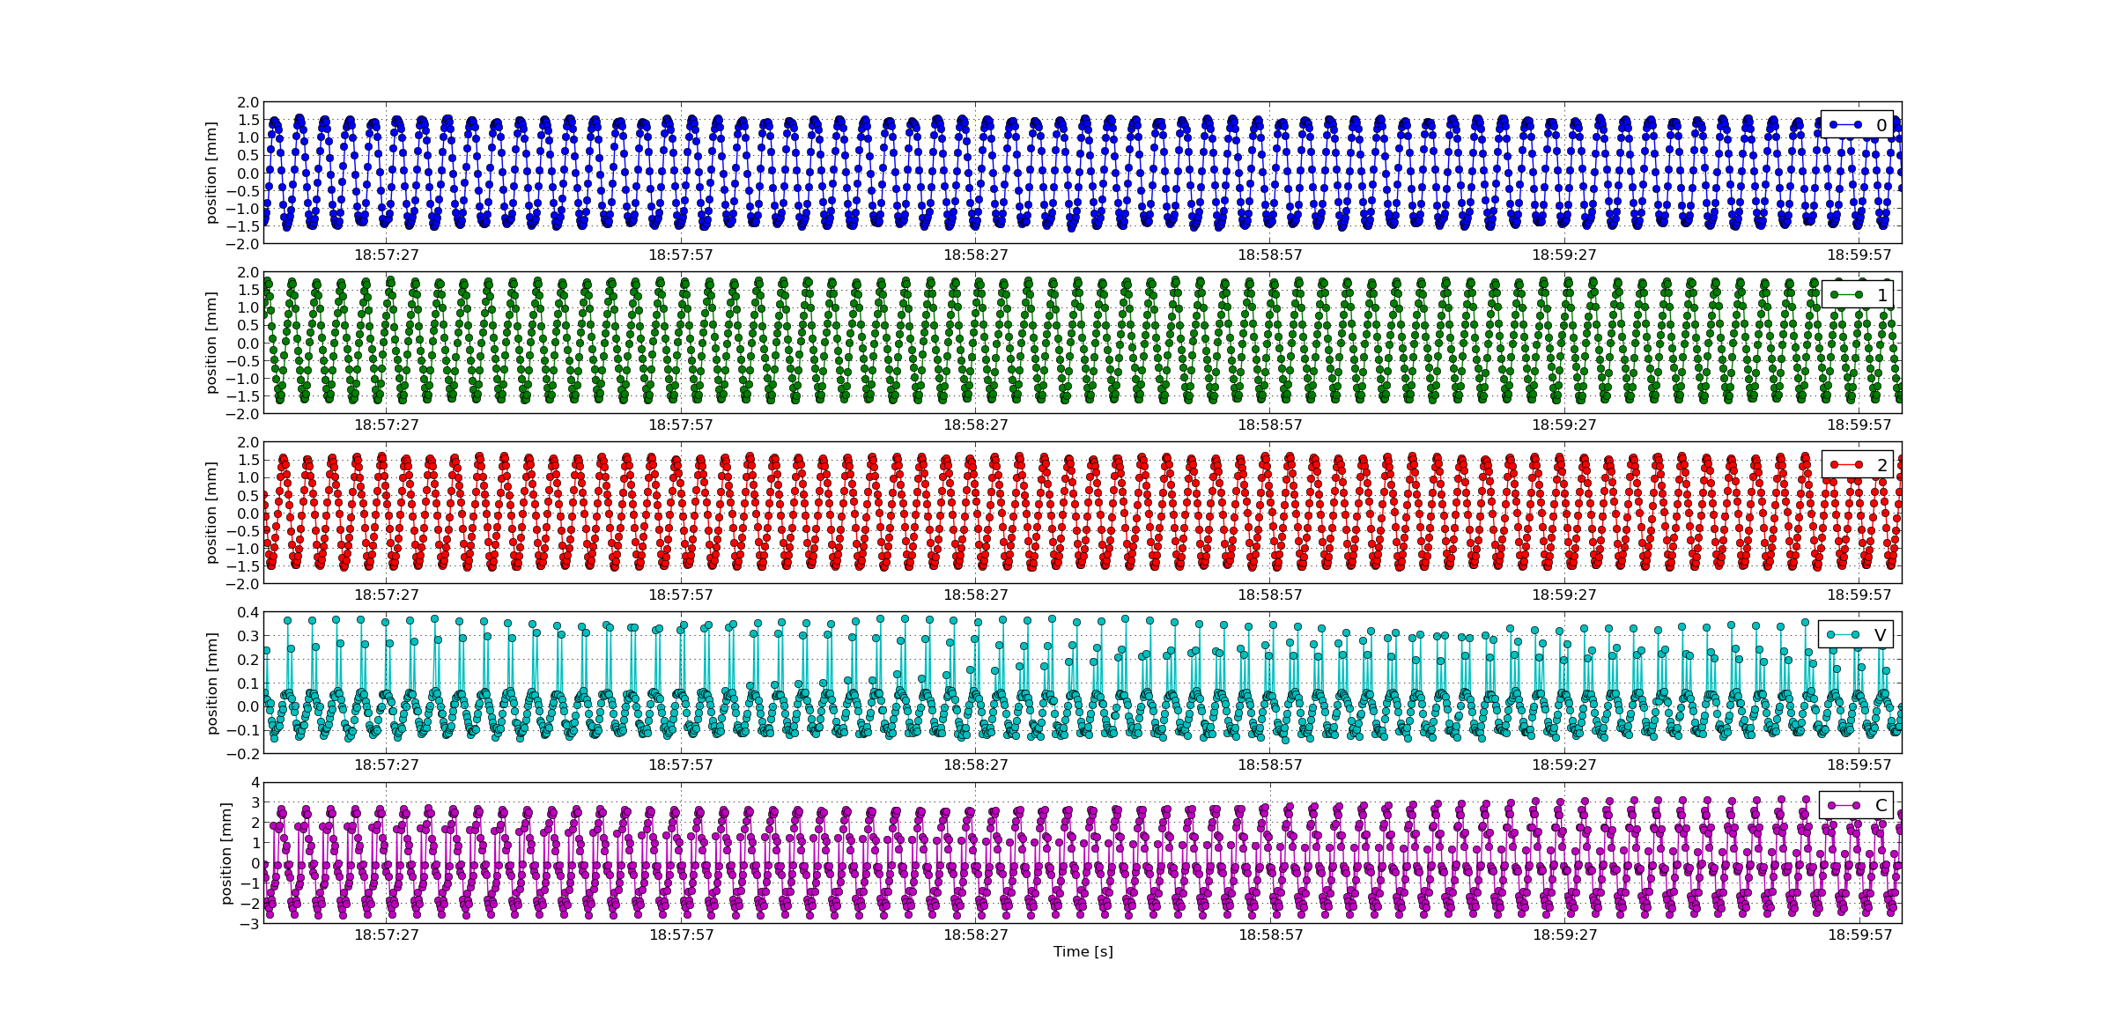

240°

Optic

Vert

120°

0°

Figure 11: Rotor positions measured with the 5 position sensors

From Figure 11 the range of displacements can be determined to be within:

* +-2 mm for horizontal position deviation
* +- 0,15 mm for vertical position deviation
* +-3 mm for horizontal deviation at the wheel circumference.

### Rotor Displacement during velocity ramp up

### Rotor displacement over 10h (horizontal pedestal sensors)

Position displacements data was recorded during a 10h long period while maintain a constant velocity of the wheel at 23rpms. The data was reduced by identifying the maximum and minimum position value for each 10s period. Figure 11 show position displacement data recorded by the sensors mounted horizontally in the pedestal (not optical sensor). Unfortunately, approx. 1h of data was lost in the timespan 14:30 to 15:30.



5

4

3

8

7

6

2

1

Figure 12: Position measurements for horizontal sensors at 0º, 120º and 240º degrees over a 10h period. Upper graph shows maximum position values and lower graph shows minimum position values. Each value is a maximum or minimum of a 10 second period.

In Figure 11, a few things can be identified (see arrows in the figure):

1. Startup ramp
2. Disturbance in position of all channels (short time)
3. Minor step change in sensor 0º and spikes in values for 0º, 120º and 240º
4. Data loss
5. Minor step change in all sensors
6. Unintentional non-planned stop and start of wheel
7. Disturbance in position (long time)
8. Trends over time
9. **Velocity ramps:**

The position disturbance is highest during ramping of velocity.

1. **Disturbance in position (short time):**

A sudden disturbance happened just before 12:00. The reason for this is not known. Could be someone climbing the structure to reach the drive unit resulting in a disturbance.

1. **Small step change in sensor 0º and spikes in values for 120º and 240º:**

Just before 14:00 a change in the movement of the wheel can be identified. The values from sensor 0º sensor shifts and noise level increase slightly. This coincides with the time of a torque increase, Figure 10. Note that there can be a few minutes shift in the data since the timestamp is from two different stand-alone computers without access to network. The reason for this increase in torque is not known.

A few minutes later a spike occurs in all three sensors.

Torque Avg [%]

1. **Data loss:**

No data during this period.

1. **Minor step change in all sensors:**

A minor change in position for all sensors can be seen. This coincides with torque going back to original level again, Figure 12.

1. **Unintentional non-planned stop and re-start of wheel:**

An unintentional stop occurred. The wheel was re-started again.

During the velocity ramps, large deviations in the position sensors can be seen. After restart the wheel seems to stabilize in a slightly different location than before the stop.

1. **Disturbance in position (long time):**

A significant disturbance in rotor position can be identified. The rotor position moves closer to the 120-degree sensor. The disturbance lasts for approx. 15 minutes and the rotor position returns to more or less the same position as before the disturbance.

1. **Trends over time**

The rotor moves slightly towards the 120-degree sensor during the test and might take even longer than 10h to stabilize.

Table 1: Statistics for horizontal pedestal sensors over a 10h period.

|  |  |  |  |  |  |  |
| --- | --- | --- | --- | --- | --- | --- |
|  | **0º**  **max** | **0º**  **min** | **120º**  **max** | **120º**  **min** | **240º**  **max** | **240º**  **min** |
| **Values []** | 3569 | 3569 | 3572 | 3572 | 3572 | 3572 |
| **Max [mm]** | **2.01** | 1.27 | **2.16** | 0.52 | **1.97** | -0.25 |
| **Min [mm]** | 0.73 | -2.01 | -0.98 | -2.05 | -1.25 | -1.86 |
| **Std [mm]** | 0.06 | 0.10 | 0.08 | 0.07 | 0.11 | 0.04 |
| **Max Range [mm]** | +-2.01 | | **+-2.16** | | +-1.97 | |

Table 1 summarizes some statistics from the data in Figure 11. The total position displacement range over 10h can be calculated to **+-2.16** mm for the pedestal sensors**.**

**Note: The raw data was sampled at 10Hz resulting in that the actual movement can be slightly larger.**

### Rotor circumference displacement over 10h (horizontal optical sensor)

The data collected from the optical sensor, mounted to measure on the circumference of the wheel is presented in Figure 13.The data show slow oscillations with a frequency at approx. four oscillations per hour. This could be related to aliasing generated by sampling rate.

A slow trend that the wheel is moving closer to the sensor over time can be observed.

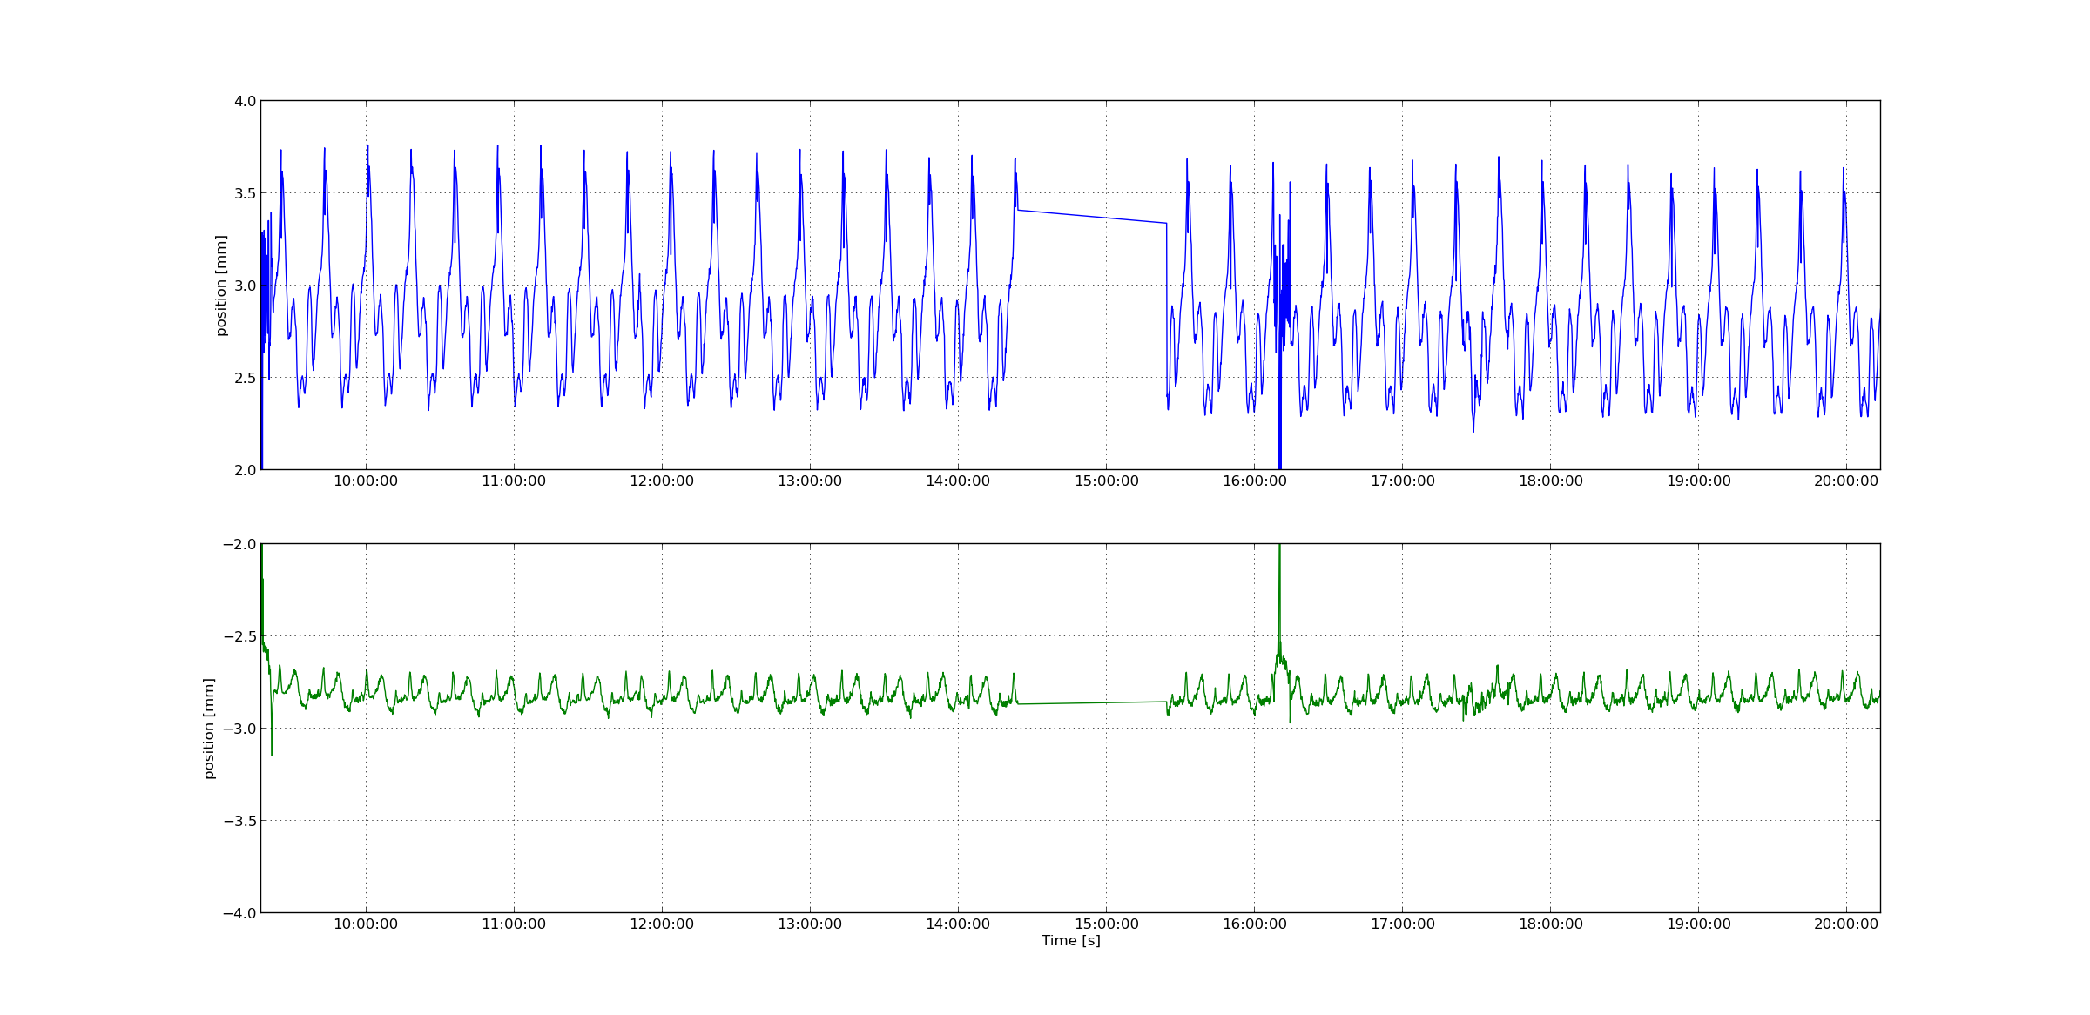

Figure 13: Position measurements for the optical sensor measuring circumference deviation over a 10h period. Upper graph shows maximum position values and lower graph shows minimum position values. Each value is a maximum or minimum of a 10 second period.

Table 2: Statistics for horizontal optical sensor measuring circumference position deviation over a 10h period

|  |  |  |
| --- | --- | --- |
|  | **Opto**  **max** | **Opto**  **min** |
| **Values []** | 3573 | 3573 |
| **Max [mm]** | **3.76** | 0.16 |
| **Min [mm]** | -1.32 | -3.15 |
| **Std [mm]** | 0.35 | 0.08 |
| **Max Range [mm]** | **+-3.76** | |

### Rotor vertical movement over 10h

# Results

Sample faster next time (100hz)

Rotor displacements:

Horizontal Circumference: +-3.76mm

Horizontal pedestal: +-2.16mm

Vertical pedestal:

## 11359 Axis 1

Table 3: Results 11359, axis 1

# CONCLUSIONS

The results of this second SAT presented in chapter 6 can be summarized as follows:

* Accuracy and repeatability:
  + All axes fulfill the requirements with good margin.
* Switches:
  + The switches identified with bent actuation brackets had been fixed/replaced.
  + 11358, axis 1 was found to have worse performance of the low limit switch compared to what was found during the first SAT test.
* Noise:
  + Mechanical grinding noise was still observed from most of the axes. However, the situation has improved a lot since the first SAT.
  + Two of the axes was almost silent.
* 11360 slit set:
  + Electrical connection was fixed and could now be tested for the first time.
  + axis 1: Mechanical grinding noise, the worst numbers of accuracy and performance of all the axes but still within spec.
  + axis2: No mechanical noise and well within spec for accuracy and repeatability.

# references

1. EtherCAT organization, <https://www.ethercat.org>
2. ecmc, open source motion control, <https://accelconf.web.cern.ch/icalepcs2017/talks/mocpl05_talk.pdf>
3. Control system configurations, <https://github.com/anderssandstrom/ecmc_target_muts_logger>
4. Micro-Epsilon laser triangulation sensor, <https://www.micro-epsilon.com/displacement-position-sensors/laser-sensor/optoNCDT_2300_basic/>
5. Telemess eddy current sensors, <https://www.telemess.de>
6. Telemess eddy current sensor calibration tables, <https://github.com/anderssandstrom/ecmc_target_muts_logger/blob/master/src/bptTypeTelemessCalib.dbd>
7. Manual torque and temperature measurements by AVS, <https://gitlab.esss.lu.se/mcag/target/target_fat_galicia_analysis/-/blob/master/doc/N046_TorqueDataRecord_16_02_2022_final.xlsm>

Document Revision history

| Revision | Reason for and description of change | Author | Date |
| --- | --- | --- | --- |
| 1 | First issue | Anders Sandström | 2021-12-20 |
|  |  |  |  |
|  |  |  |  |

# Appendix A Micro Epsilon ILD2300 Calibration REPORT



# Appendix B: Telemess A30-S01



# Appendix C: Telemess A42

